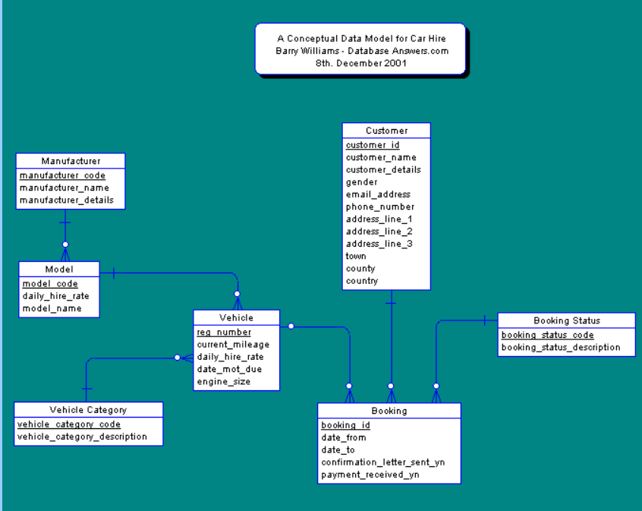

Prepare CREATE TABLE STATEMENT based on your understanding of data types and width of mentioned entities.

Note: Please do not enforce any constraints as of now